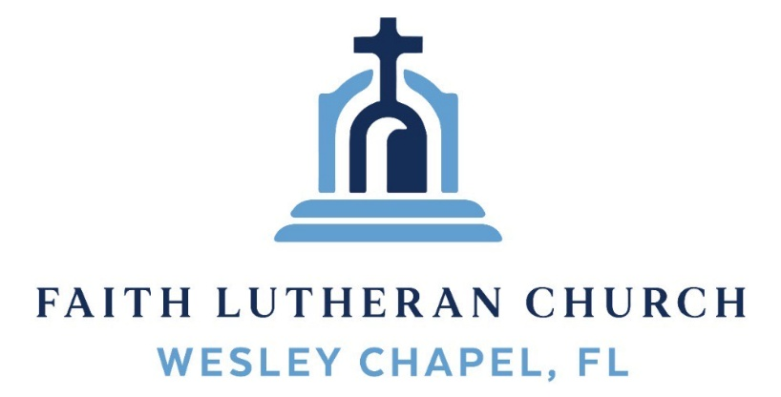
Leading our community into a deep connection in Christ

Worship Service for May 10, 2026 at 11 AM
Welcome
Invocation (stand)
Confession and Forgiveness: (stand)
P: As we gather, today, let us cleanse our hearts and our consciences by confessing our sin to God.
(Time of silence for reflection and confession)
C: Heavenly Father, we confess that we are sinful and unclean. We have sinned against you and against our neighbor in our thoughts, words, and actions. We are truly sorry for our sins and sincerely repent of them. We ask for Your mercy. For the sake of Jesus Christ's bitter suffering and death, please forgive us and renew us that we may walk in Your Spirit to the glory of Your holy name. Amen
P: The Lord has heard your confession. Therefore, as a called and ordained servant of the Lord, in the stead and by the command of my Lord, Jesus Christ, I forgive you all your sins in the name of the Father and of the Son and of the Holy Spirit.
C: Amen

Songs of Praise and Thanksgiving – What An Awesome God (sit)
God is great. Give Him all the praise.
Hallelujah, Name above all Names. Fire in His eyes.
Healing in His veins, everywhere His glory on display.
Take a look at those stars, He can name them all.
Before His throne every knee falls.
The demons have to run. The angels have to praise.
Even the wind and waves obey
Chorus 1:
Our God is an awesome God. He reigns from heaven above,
With wisdom, power and love, our God is an awesome God
(Repeat)
And even when I ran, He didn’t run away.
He came and put death back in its place.
Friday on a cross, broken for my shame.
Sunday morning rose up from that grave.
Take a look at those scars on His hands and feet.
He saved our souls for eternity.
Worthy is the Lamb. Glory to the King.
Oh, let all the saints and the angels sing.
(Chorus 1)
Eyes on the sky. There will be a day.
He will come and wipe our tears away.
No more fear, no more pain. No more sorrow, sin, or shame.
The King is coming back again, a reign of love that will never end.
For everything You’ve done and everything You do,
And everything You are I’ll sing to You.
Chorus 2:
My God, You’re an awesome God. You’re great in all You do
I’m made to worship You. My God, You’re an awesome God
(Chorus 1)
Our God is an awesome God. Our God, what an awesome God
© 2025 Universal Music
Old Testament Reading: Acts 17:16-34
Now while Paul was waiting for them at Athens, his spirit was provoked within him as he saw that the city was full of idols. So he reasoned in the synagogue with the Jews and the devout persons, and in the marketplace every day with those who happened to be there. Some of the Epicurean and Stoic philosophers also conversed with him. And some said, “What does this babbler wish to say?” Others said, “He seems to be a preacher of foreign divinities”—because he was preaching Jesus and the resurrection. And they took him and brought him to the Areopagus, saying, “May we know what this new teaching is that you are presenting? For you bring some strange things to our ears. We wish to know therefore what these things mean.” Now all the Athenians and the foreigners who lived there would spend their time in nothing except telling or hearing something new.
So Paul, standing in the midst of the Areopagus, said: “Men of Athens, I perceive that in every way you are very religious. For as I passed along and observed the objects of your worship, I found also an altar with this inscription: ‘To the unknown god.’ What therefore you worship as unknown, this I proclaim to you. The God who made the world and everything in it, being Lord of heaven and earth, does not live in temples made by man, nor is he served by human hands, as though he needed anything, since he himself gives to all mankind life and breath and everything. And he made from one man every nation of mankind to live on all the face of the earth, having determined allotted periods and the boundaries of their dwelling place, that they should seek God, and perhaps feel their way toward him and find him. Yet he is actually not far from each one of us, for
“‘In him we live and move and have our being’; as even some of your own poets have said, “‘For we are indeed his offspring.’
Being then God's offspring, we ought not to think that the divine being is like gold or silver or stone, an image formed by the art and imagination of man. The times of ignorance God overlooked, but now he commands all people everywhere to repent, because he has fixed a day on which he will judge the world in righteousness by a man whom he has appointed; and of this he has given assurance to all by raising him from the dead.”
Now when they heard of the resurrection of the dead, some mocked. But others said, “We will hear you again about this.” So Paul went out from their midst. But some men joined him and believed, among whom also were Dionysius the Areopagite and a woman named Damaris and others with them.
Reader: This is the Word of the Lord.
C: Thanks be to God.
Epistle Reading: 1 Peter 3:18-22
For Christ also suffered once for sins, the righteous for the unrighteous, that he might bring us to God, being put to death in the flesh but made alive in the spirit, in which he went and proclaimed to the spirits in prison, because they formerly did not obey, when God's patience waited in the days of Noah, while the ark was being prepared, in which a few, that is, eight persons, were brought safely through water. Baptism, which corresponds to this, now saves you, not as a removal of dirt from the body but as an appeal to God for a good conscience, through the resurrection of Jesus Christ, who has gone into heaven and is at the right hand of God, with angels, authorities, and powers having been subjected to him.
Reader: This is the Word of the Lord.
C: Thanks be to God.
Gospel Reading - John 14:15-21
“If you love me, you will keep my commandments. And I will ask the Father, and he will give you another Helper, to be with you forever, even the Spirit of truth, whom the world cannot receive, because it neither sees him nor knows him. You know him, for he dwells with you and will be in you.
“I will not leave you as orphans; I will come to you. Yet a little while and the world will see me no more, but you will see me. Because I live, you also will live. In that day you will know that I am in my Father, and you in me, and I in you. Whoever has my commandments and keeps them, he it is who loves me. And he who loves me will be loved by my Father, and I will love him and manifest myself to him.”
P: This is the Gospel of the Lord.
C: Praise be to You, O Christ.
Sermon Song – Cornerstone
My hope is built on nothing less,
Than Jesus' blood and righteousness.
I dare not trust the sweetest frame,
But wholly trust in Jesus' name.
Chorus:
Christ alone, Cornerstone, Weak made strong in the Savior's love.
Through the storm He is Lord, Lord of all.

When darkness seems to hide His face,
I rest on His unchanging grace.
In every high and stormy gale My anchor holds within the veil.
My anchor holds within the veil.

(Chorus)

He is Lord. Lord of all.

Verse 3:
When He shall come with trumpet sound,
Oh, may I then in Him be found,
Dressed in His righteousness alone,
Faultless, stand before the throne.

(Chorus) © 2011 Hillsong Music
Sermon/Discussion – "In Every Way Spiritual"
Prayers
Apostles' Creed (stand)
I believe in God, the Father almighty, maker of heaven and earth,
And in Jesus Christ, his only Son, our Lord,
who was conceived by the Holy Spirit,
born of the Virgin Mary, suffered under Pontius Pilate,
was crucified, died and was buried. He descended into hell.
The third day he rose again from the dead.
He ascended into heaven and sits at the right hand of God
the Father almighty.
From there he will come to judge the living and the dead.
I believe in the Holy Spirit, the holy Christian Church,
the communion of saints, the forgiveness of sins,
the resurrection of the body, and the life everlasting. Amen.
Mother’s Day Prayer
The Lord's Prayer (stand)
Our Father who art in heaven, hallowed be Thy name, Thy kingdom come, Thy will be done on earth as it is in heaven. Give us this day our daily bread; and forgive us our trespasses as we forgive those who trespass against us; and lead us not into temptation, but deliver us from evil. For Thine is the kingdom and the power and the glory forever and ever. Amen
Benediction (stand)
Closing Song: Praise God From Whom All Blessings Flow (stand)
Praise God from Whom all blessings flow.
Praise Him all creatures here below.
Praise Him above, ye heavenly hosts.
Praise Father, Son and Holy Ghost.
Amen

Serving This Week
O.T. Reader: Richard Steinbrueck | Children’s Church Teacher:
Epistle Reader: Darlene Mueller | Melissa Steinbrueck
Acolyte: Eli Bingaman | Children’s Church Assistant:
Com. Asst: Larry Chmiel | Kaylee Steinbrueck
Serving Next Week
O.T. Reader: Josh Strasheim | Children’s Church Teacher:
Epistle Reader: Ben Pike | Halston and Ben
Acolyte: Kaylee Steinbrueck | Children’s Church Assistant:
Com. Asst: Richard Steinbrueck | N/A

LCMS Foundation:
A good gift plan within an estate includes inheritance for family and gifts to ministry. Some might consider this a difficult task. How does an LCMS Foundation Gift Planning Counselor help? Working on your estate can be complicated as you balance legal, tax and financial issues, along with your desires to care for family and support ministry. Your LCMS Foundation Gift Planning Counselor has tools to organize all these things.
Contact Tony Hunt 260-222-1291 or tony.hunt@lfnd.org

Offering (sit) Give online at:

Upcoming Events
May 12, 7 PM – Church Council Meeting
Larry’s Home
May 14, 7 PM – In-Person Growth Group Bible Study
Renee’s Home
May 14, 7 PM – Online Growth Group Bible Study
Zoom
May 17, 11 AM – Police and Armed Services Sunday
Faith Lutheran Church
May 17, 3:30-5:45 PM – Youth Group – Main Event
Main Event by Tampa Premium Outlets

www.FaithWesleyChapel.com

Faith YouTube
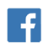
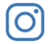
@FaithWesleyChapel
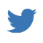
@FaithWesleyChapel
@FaithChurchWC

