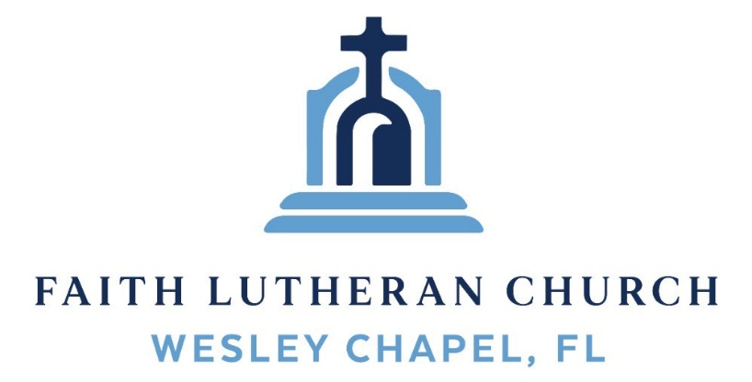
Leading our community into a deep connection in Christ

Worship Service for August 23, 2026 at 11 AM
Welcome and Opening Song: Thy Strong Word
Thy strong word did cleave the darkness;
At Thy speaking it was done.
For created light we thank Thee,
While Thine ordered seasons run.

Refrain:
Alleluia, alleluia! Praise to Thee who light dost send!
Alleluia, alleluia! Alleluia without end!
Lo, on those who dwelt in darkness,
Dark as night and deep as death,
Broke the light of thy salvation,
Breathed thine own life-giving breath. (Refrain)

Thy strong Word bespeaks us righteous;
Bright with thine own holiness,
Glorious now, we press toward glory,
And our lives our hope confess. (Refrain)

Give us lips to sing thy glory, Tongues thy mercy to proclaim,
Throats to shout the hope that fills us,
Mouths to speak thy holy name. (Refrain)

Invocation and Confession and Forgiveness:
P: Come into the presence of God. It is God, Himself, who bids us to come to Him in prayer, especially when we have sinned, so that we may receive His forgiveness. So, we enter His courts with confidence that if we confess our sins, He will forgive us as He promised.
(A time of silence to reflect and personally confess our sins)
C: Heavenly Father, we confess that we have sinned against you in thought, word, and deed. We have not loved you with our whole heart and have not loved our neighbor as ourselves. We are truly sorry and we humbly repent. For the sake of your Son Jesus Christ and His suffering and death on the cross, have mercy on us and forgive us; that we may delight in your will, and walk in your ways, to the glory of your Name. Amen
P: Words of Forgiveness
C: Amen.
Song of Praise and Thanksgiving - Cornerstone
My hope is built on nothing less,
Than Jesus' blood and righteousness.
I dare not trust the sweetest frame,
But wholly trust in Jesus' name.
Chorus:
Christ alone, Cornerstone, Weak made strong in the Savior's love.
Through the storm He is Lord, Lord of all.

When darkness seems to hide His face,
I rest on His unchanging grace.
In every high and stormy gale My anchor holds within the veil.
My anchor holds within the veil.

(Chorus)

He is Lord. Lord of all.

When He shall come with trumpet sound,
Oh, may I then in Him be found,
Dressed in His righteousness alone,
Faultless, stand before the throne. © 2011 Hillsong Music

Old Testament Reading - Isaiah 55:8-11
For my thoughts are not your thoughts, neither are your ways my ways, declares the Lord. For as the heavens are higher than the earth, so are my ways higher than your ways and my thoughts than your thoughts.
“For as the rain and the snow come down from heaven and do not return there but water the earth, making it bring forth and sprout, giving seed to the sower and bread to the eater, so shall my word be that goes out from my mouth; it shall not return to me empty, but it shall accomplish that which I purpose, and shall succeed in the thing for which I sent it.
Reader: This is the Word of the Lord. C: Thanks be to God.
Epistle Reading - Colossians 2:6-15
Therefore, as you received Christ Jesus the Lord, so walk in him, rooted and built up in him and established in the faith, just as you were taught, abounding in thanksgiving.
See to it that no one takes you captive by philosophy and empty deceit, according to human tradition, according to the elemental spirits of the world, and not according to Christ. For in him the whole fullness of deity dwells bodily, and you have been filled in him, who is the head of all rule and authority. In him also you were circumcised with a circumcision made without hands, by putting off the body of the flesh, by the circumcision of Christ, having been buried with him in baptism, in which you were also raised with him through faith in the powerful working of God, who raised him from the dead. And you, who were dead in your trespasses and the uncircumcision of your flesh, God made alive together with him, having forgiven us all our trespasses, by canceling the record of debt that stood against us with its legal demands. This he set aside, nailing it to the cross. He disarmed the rulers and authorities and put them to open shame, by triumphing over them in him.
Reader: This is the Word of the Lord. C: Thanks be to God.
Gospel Reading - Matthew 7:13-29
“Enter by the narrow gate. For the gate is wide and the way is easy that leads to destruction, and those who enter by it are many. For the gate is narrow and the way is hard that leads to life, and those who find it are few.
“Beware of false prophets, who come to you in sheep's clothing but inwardly are ravenous wolves. You will recognize them by their fruits. Are grapes gathered from thornbushes, or figs from thistles? So, every healthy tree bears good fruit, but the diseased tree bears bad fruit. A healthy tree cannot bear bad fruit, nor can a diseased tree bear good fruit. Every tree that does not bear good fruit is cut down and thrown into the fire. Thus you will recognize them by their fruits.
“Not everyone who says to me, ‘Lord, Lord,’ will enter the kingdom of heaven, but the one who does the will of my Father who is in heaven. On that day many will say to me, ‘Lord, Lord, did we not prophesy in your name, and cast out demons in your name, and do many mighty works in your name?’ And then will I declare to them, ‘I never knew you; depart from me, you workers of lawlessness.’
“Everyone then who hears these words of mine and does them will be like a wise man who built his house on the rock. And the rain fell, and the floods came, and the winds blew and beat on that house, but it did not fall, because it had been founded on the rock. And everyone who hears these words of mine and does not do them will be like a foolish man who built his house on the sand. And the rain fell, and the floods came, and the winds blew and beat against that house, and it fell, and great was the fall of it.”
And when Jesus finished these sayings, the crowds were astonished at his teaching, for he was teaching them as one who had authority, and not as their scribes.
P: This is the Gospel of the Lord. C: Praise be to You, O Christ.
Children's Message (Children dismissed to Children's Church)
Sermon Hymn - A Mighty Fortress Is Our God
A mighty fortress is our God, a bulwark never failing;
Our helper He, amid the flood of mortal ills prevailing.
For still our ancient foe does seek to work us woe;
His craft and power are great and armed with cruel hate.
On earth is not his equal.
Did we in our own strength confide our striving would be losing.
Were not the right Man on our side,
The Man of God's own choosing.
You ask who that may be? Christ Jesus, it is he;
Lord Sabaoth His name, from age to age the same;
And He must win the battle.
And though this world, with devils filled,
Should threaten to undo us.
We will not fear, for God has willed,
His truth to triumph through us.
The prince of darkness grim, we tremble not for him.
His rage we can endure, for lo! his doom is sure.
One little word shall fell him.
That Word above all earthly powers no thanks to them abideth;
The Spirit and the gifts are ours through Him who with us sideth.
Let goods and kindred go, this mortal life also.
The body they may kill: God's truth abideth still!
His kingdom is forever. © Public Domain
Sermon - "The Hidden Attack of Messages of the World"
Prayers: Text in prayer requests to (813) 326-5255‬
Nicene Creed (stand)
I believe in one God, the Father Almighty, maker of heaven and earth and of all things visible and invisible.
And in one Lord Jesus Christ, the only-begotten Son of God, begotten of His Father before all worlds, God of God, Light of Light, very God of very God, begotten, not made, being of one substance with the Father, by whom all things were made; who for us men and for our salvation came down from heaven and was incarnate by the Holy Spirit of the virgin Mary and was made man; and was crucified also for us under Pontius Pilate. He suffered and was buried. And the third day He rose again according to the Scriptures and ascended into heaven and sits at the right hand of the Father. And He will come again with glory to judge both the living and the dead, whose kingdom will have no end.
And I believe in the Holy Spirit, the Lord and Giver of Life, who proceeds from the Father and the Son, who with the Father and the Son together is worshiped and glorified, who spoke by the prophets. And I believe in one holy Christian and apostolic Church, I acknowledge one Baptism for the remission of sins, and I look for the resurrection of the dead and the life of the world to come. Amen.
The Lord's Prayer (stand)
Our Father who art in heaven, hallowed be Thy name, Thy kingdom come, Thy will be done on earth as it is in heaven. Give us this day our daily bread; and forgive us our trespasses as we forgive those who trespass against us; and lead us not into temptation, but deliver us from evil. For Thine is the kingdom and the power and the glory forever and ever. Amen
Distribution
Benediction (The online service ends. The closing song can be found as a YouTube video at FaithWesleyChapel.com/bulletin)
Thank you for joining Faith for worship. We hope to see you in person soon!
Closing Song - We Believe
In this time of desperation, when all we know is doubt and fear, There is only One foundation. We believe. We believe.
In this broken generation, when all is dark, You help us see.
There is only One salvation. We believe. We believe
Chorus:
We believe in God the Father. We believe in Jesus Christ.
We believe in the Holy Spirit, and He's given us new life.
We believe in the crucifixion.
We believe that He conquered death.
We believe in the resurrection,
And He's comin' back again we believe
So, let our faith be more than anthems,
Greater than the songs we sing.
And in our weakness and temptations,
We believe! We believe!
(Chorus)
Let the lost be found and the dead be raised!
In the here and now, let love invade!
Let the church live loud, in our God will say
We believe! We believe!
And the gates of hell will not prevail!
For the power of God has torn the veil!
Now we know Your love will never fail!
We believe! We believe!
(Chorus) © Abundant Life Ministries UK, Integrity worship Music

Serving This Week
O.T. Reader: Ginger Dunn | Children’s Church Teacher:
Epistle Reader: Ben Pike | Halston & Ben
Acolyte: Eli Steinbrueck | Children’s Church Assistant:
Offering: Heidi Strasheim | N/A
Com. Asst: Larry Chmiel
Serving Next Week
1st Reader: Kaylee Steinbrueck | Children’s Church Teacher:
2nd Reader: Thomas Horness | N/A – No Children’s Church
Acolyte: Lawrence Finnerty  Offering/Comm: Heidi Strasheim | Children’s Church Assistant:
Com. Asst: Larry Chmiel | N/A – No Children’s Church

Upcoming Events
Today, After the Service – Build Our Faith Planning Meeting
Faith Lutheran Church
Today, 1:15 PM – Escape Room - Faith and Grace Youth Activity
Meet at Grace Community Church (Then, we’ll drive to Checkmate Escape Room)
Sept. 3, 7 PM – Growth Group Bible Study (Online)
Zoom
Date/Time TBD – Pack a Sack Packing Party
TBD – We will be emailing info. Deliveries start Sept 9.

www.FaithWesleyChapel.com

Faith YouTube
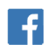
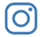
@FaithWesleyChapel
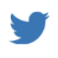
@FaithWesleyChapel
@FaithChurchWC

