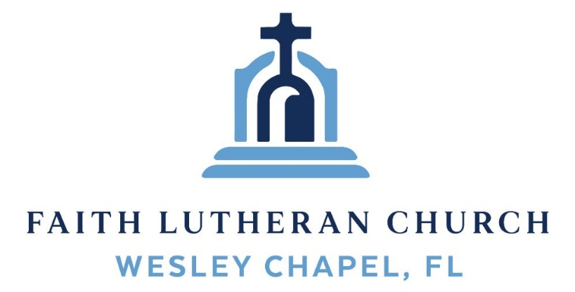
Leading our community into a deep connection in Christ
___________________________________________________
Worship Service for October 4, 2026 at 11 AM
Welcome
Opening Song: I Am a C-H-R-I-S-T-I-A-N
I am C
I am C-H
I am C-H-R-I-S-T-I-A-N
And I have C-H-R-I-S-T
In my H-E-A-R-T
And I will L-I-V-E-E-T-E-R-N-A-L-L-Y © 1992 Word Music, LLC
Invocation
Confession and Forgiveness:
P: We have come here today to worship the Lord. In worship we hear the Word of God, we receive God's blessings, and respond with thanks and praise. We begin by seeking God's blessing of forgiveness. He has promised to remove the guilt and shame of our sin through the sacrifice of Jesus Christ on the cross.
(a time of silence to reflect and personally confess our sins)
P: Let us confess our sins to the Lord.
P: Heavenly Father,
C: Heavenly Father,
P: I have done things that were wrong.
C: I have done things that were wrong.
P: I have been mean to others.
C: I have been mean to others.
P: I have not obeyed my parents.
C: I have not obeyed my parents.
P: I have not obeyed You, God.
C: I have not obeyed You, God.
P: But I am very sorry.
C: But I am very sorry.
P: Please forgive me.
C: Please forgive me.
P: I love You very much.
C: I love You very much.
P: And I know You love me, too.
C: And I know You love me, too.
P: Amen.
C: Amen.
P: God has heard your apology. He loves you very much. God has told us that when we believe and trust in Him, He makes us His children. As far as the east is from the west, so far does he remove our sins from us. He has told me to tell you that you are forgiven. So, as His servant, I forgive you in the name of the Father and of the Son and of the Holy Spirit.
C: Amen.
Song: God Is So Good
God is so good. God is so good.
God is so good. He's so good to me.
He died for me. He died for me so.
He died for me. He's so good to me.
He loves me so. He loves me so.
He loves me so. He's so good to me. © Public Domain
First Reading – Philippians 3:8b

Because of Christ, I lost all these things, and now I know that they are all worthless trash. All I want now is Christ.

Reader: This is the Word of the Lord.
C: Thanks be to God.
Children's Message "What Really Matters"

Song: Jesus Messiah
He became sin, who knew no sin,
That we might become His Righteousness.
He humbled Himself and carried the cross.
Love so amazing, love so amazing!
Chorus:
Jesus Messiah, Name above all names,
Blessed Redeemer, Emmanuel,
The rescue for sinners, the ransom from Heaven,
Jesus Messiah, Lord of all.
His body the bread, His blood the wine,
Broken and poured out all for love.
The whole earth trembled and the veil was torn.
Love so amazing, love so amazing!
(Chorus)
All our hope is in You. All our hope is in You.
All the glory to You, God, The light of the world.
(Chorus)
Jesus Messiah, Lord of all. He is the Lord of all! Lord of all.
© 2008 Vamos Publishing and Alletrop Music
Second Reading - Philippians 3:8b-9
For his sake I have suffered the loss of all things and count them as rubbish, in order that I may gain Christ and be found in him, not having a righteousness of my own that comes from the law, but that which comes through faith in Christ, the righteousness from God that depends on faith
Reader: This is the Word of the Lord.
C: Thanks be to God.
Children's Message "Law vs Gospel"
Gospel Reading – Matthew 21:33-46
“Hear another parable. There was a master of a house who planted a vineyard and put a fence around it and dug a winepress in it and built a tower and leased it to tenants, and went into another country. When the season for fruit drew near, he sent his servants to the tenants to get his fruit. And the tenants took his servants and beat one, killed another, and stoned another. Again he sent other servants, more than the first. And they did the same to them. Finally he sent his son to them, saying, ‘They will respect my son.’ But when the tenants saw the son, they said to themselves, ‘This is the heir. Come, let us kill him and have his inheritance.’ And they took him and threw him out of the vineyard and killed him. When therefore the owner of the vineyard comes, what will he do to those tenants?” They said to him, “He will put those wretches to a miserable death and let out the vineyard to other tenants who will give him the fruits in their seasons.”
Jesus said to them, “Have you never read in the Scriptures:
“‘The stone that the builders rejected
has become the cornerstone;
this was the Lord's doing,
and it is marvelous in our eyes’?
Therefore I tell you, the kingdom of God will be taken away from you and given to a people producing its fruits. And the one who falls on this stone will be broken to pieces; and when it falls on anyone, it will crush him.”
When the chief priests and the Pharisees heard his parables, they perceived that he was speaking about them. And although they were seeking to arrest him, they feared the crowds, because they held him to be a prophet.
P: This is the Gospel of the Lord.
C: Praise be to You, O Christ.
Song: Cornerstone
My hope is built on nothing less,
Than Jesus' blood and righteousness.
I dare not trust the sweetest frame,
But wholly trust in Jesus' name.
Chorus:
Christ alone, Cornerstone, Weak made strong in the Savior's love.
Through the storm He is Lord, Lord of all.

Verse 2:
When darkness seems to hide His face,
I rest on His unchanging grace.
In every high and stormy gale My anchor holds within the veil.
My anchor holds within the veil.

(Chorus)

He is Lord. Lord of all.

Verse 3:
When He shall come with trumpet sound,
Oh, may I then in Him be found,
Dressed in His righteousness alone,
Faultless, stand before the throne.

(Chorus) © 2011 Hillsong Music
Sermon – "Broken but Not Crushed"
Prayers: Text in prayer requests to (813) 326-5255
The Lord's Prayer

Our Father who art in heaven, hallowed be Thy name, Thy kingdom come, Thy will be done on earth as it is in heaven. Give us this day our daily bread; and forgive us our trespasses as we forgive those who trespass against us; and lead us not into temptation, but deliver us from evil. For Thine is the kingdom and the power and the glory forever and ever. Amen
Offering & Commitment Cards Give online at:
Distribution
Benediction (The online service ends. The closing song can be found as a YouTube video at FaithWesleyChapel.com/bulletin)
Thank you for joining Faith for worship. We hope to see you in person soon!
Closing Song - Closing Song: The Church’s One Foundation
The church's one foundation is Jesus Christ, her Lord;
She is his new creation by water and the Word:
From heav'n he came and sought her to be his holy bride;
With his own blood he bought her, and for her life he died.
Elect from ev’ry nation, yet one o'er all the earth,
Her charter of salvation one Lord, one faith, one birth;
One holy name she blesses, partakes one holy food,
And to one hope she presses, with ev'ry grace endued.
Through toil and tribulation, and tumult of her war,
She waits the consummation of peace forevermore;
Till with the vision glorious her longing eyes are blest,
And the great church victorious shall be the church at rest.

Yet she on earth hath union with God the Three in One,
And mystic sweet communion with those whose rest is won:
O blessed heav'nly chorus! Lord, save us by Your grace,
That we, like saints before us, may see You face to face. © Public Domain

Serving This Week
1st Reader: Eli Steinbrueck | Children’s Church Teacher:
2nd Reader: Thomas Horness | N/A – No Children’s Church
Acolyte: Lawrence Finnerty  Offering & Com: Heidi Strasheim | Children’s Church Assistant:
Com. Asst: Larry Chmiel | N/A – No Children’s Church
Serving Next Week
O.T. Reader: Richard Steinbrueck | Children’s Church Teacher:
Epistle Reader: Ginger Dunn | Melissa Steinbrueck
Acolyte: Eli Bingaman | Children’s Church Assistant:
Com. Asst: Richard Steinbrueck | Kaylee Steinbrueck

Upcoming Events
Today, During Service – Commitment Sunday
Faith Lutheran Church
Today, After the Service – Pack a Sack Packing Party
Faith Lutheran Church
Oct 8, 7 PM – Online Growth Group Bible Study
Zoom
Oct 11, After the Service – In-person Bible Study
Faith Lutheran Church
Oct. 25, 11 AM – Friendship Sunday
Faith Lutheran Church



