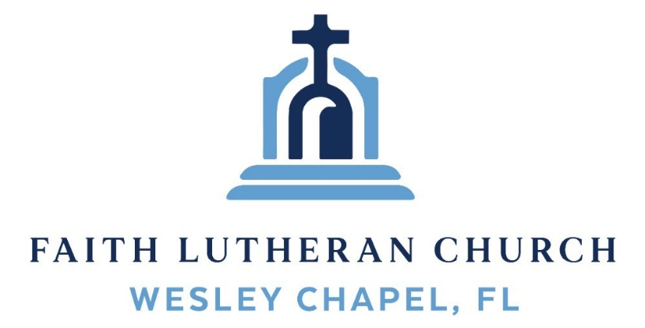
Leading our community into a deep connection in Christ

Worship Service for November 1, 2026 at 11 AM
Welcome and Opening Song: Oh, You Can't Get to Heaven
Oh, you can't get to heaven, (Oh, you can't get to heaven,)
On roller skates. (On roller skates.)
Oh, you can't get to heaven, (Oh, you can't get to heaven,)
On roller skates.
Oh, you can't get to heaven on roller skates,
'Cause you'd roll right past those pearly gates.
All my sins are washed away. I've been redeemed.
Oh, you can't get to heaven in a limousine…
'Cause the Lord don't sell no gasoline.
Oh, you can't get to Heaven in dirty jeans…
'Cause heaven ain’t got no washing machines.
If you wanna get to heaven believe in Jesus name…
'Cause it's by His name that we are saved. © Public Domain
Invocation
Confession and Forgiveness:
P: We have come here today to worship the Lord. In worship we hear the Word of God, we receive God's blessings, and respond with thanks and praise. We begin by seeking God's blessing of forgiveness. He has promised to remove the guilt and shame of our sin through the sacrifice of Jesus Christ on the cross.
(a time of silence to reflect and personally confess our sins)
P: Let us confess our sins to the Lord.
P: Heavenly Father, C: Heavenly Father,
P: I have done things that were wrong.
C: I have done things that were wrong.
P: I have been mean to others. C: I have been mean to others.
P: I have not obeyed my parents.
C: I have not obeyed my parents.
P: I have not obeyed You, God. C: I have not obeyed You, God.
P: But I am very sorry. C: But I am very sorry.
P: Please forgive me. C: Please forgive me.
P: I love You very much. C: I love You very much.
P: And I know You love me, too. C: And I know You love me, too.
P: Amen. C: Amen.
P: Words of Forgiveness
C: Amen.
Song: Jesus Loves Me
Jesus loves me this I know, For the Bible tells me so.
Little ones to Him belong, They are weak, but He is strong.

Chorus:
Yes, Jesus loves me, Yes, Jesus loves me,
Yes, Jesus loves me, The Bible tells me so.

Jesus loves me, He who died. Heaven's gates to open wide.
He will wash away my sin, Let His little child come in.
(Chorus) © Public Domain
First Reading – Revelation 7:9-10

Then I looked, and there was a large crowd of people. There were so many people that no one could count them all. They were from every nation, tribe, race of people, and language of the earth. They were standing before the throne and before the Lamb. They all wore white robes and had palm branches in their hands. They shouted loudly, “Salvation belongs to our God, who sits on the throne, and to the Lamb.”

Reader: This is the Word of the Lord.
C: Thanks be to God.
Children's Message "Jesus Overcame Death"
Song: O Praise The Name (Anástasis)
I cast my mind to Calvary Where Jesus bled and died for me.
I see His wounds, His hands, His feet.
My Savior on that cursed tree.
His body bound and drenched in tears.
They laid Him down in Joseph's tomb.
The entrance sealed by heavy stone, Messiah still and all alone.
Chorus:
O praise the Name of the Lord our God.
O praise His Name forevermore.
For endless days, we will sing Your praise, Oh Lord, oh Lord our God.
Then on the third, at break of dawn, The Son of heaven rose again.
O trampled death, where is your sting.
The angels roar for Christ the King.

(Chorus)
He shall return in robes of white.
The blazing sun shall pierce the night.
And I will rise among the saints, My gaze transfixed on Jesus' face.
(Chorus 2x) © 2015 © Hillsong Music Publishing
Second Reading - 1 John 3:1-3
See what kind of love the Father has given to us, that we should be called children of God; and so we are. The reason why the world does not know us is that it did not know him. Beloved, we are God's children now, and what we will be has not yet appeared; but we know that when he appears we shall be like him, because we shall see him as he is. And everyone who thus hopes in him purifies himself as he is pure.
Reader: This is the Word of the Lord.
C: Thanks be to God.
Children's Message "Our True Home"
Gospel Reading – Matthew 5:1-12
Seeing the crowds, he went up on the mountain, and when he sat down, his disciples came to him.
And he opened his mouth and taught them, saying:
“Blessed are the poor in spirit, for theirs is the kingdom of heaven.
“Blessed are those who mourn, for they shall be comforted.
“Blessed are the meek, for they shall inherit the earth.
BBlessed are those who hunger and thirst for righteousness, for they shall be satisfied.
“Blessed are the merciful, for they shall receive mercy.
“Blessed are the pure in heart, for they shall see God.
“Blessed are the peacemakers, for they shall be called sons of God.
“Blessed are those who are persecuted for righteousness' sake, for theirs is the kingdom of heaven.
“Blessed are you when others revile you and persecute you and utter all kinds of evil against you falsely on my account. Rejoice and be glad, for your reward is great in heaven, for so they persecuted the prophets who were before you.
P: This is the Gospel of the Lord.
C: Praise be to You, O Christ.
Song: For All The Saints
For all the saints who from their labors rest,
Who Thee by faith before the world confessed,
Thy name, O Jesus, be forever blest. Alleluia! Alleluia!
Thou wast their rock, their fortress, and their might;
Thou, Lord, their captain in the well-fought fight;
Thou, in the darkness drear, their one true light. Alleluia! Alleluia!
Oh, may Thy soldiers, faithful, true, and bold,
Fight as the saints who nobly fought of old;
And win with them the victor's crown of gold! Alleluia! Alleluia!
The golden ev'ning brightens in the west.
Soon, soon to faithful warriors cometh rest.
Sweet is the calm of paradise the blest. Alleluia! Alleluia!
But lo, there breaks a yet more glorious day;
The saints triumphant rise in bright array;
The King of Glory passes on His way. Alleluia! Alleluia!
From earth's wide bounds, from ocean's farthest coast,
Through gates of pearl streams in the countless host,
Singing to Father, Son, and Holy Ghost: Alleluia! Alleluia!
© Public Domain
Sermon – "Who Are These, Clothed in White Robes"
Sermon Text: Revelation 7:11-17
And all the angels were standing around the throne and around the elders and the four living creatures, and they fell on their faces before the throne and worshiped God, saying, “Amen! Blessing and glory and wisdom and thanksgiving and honor and power and might be to our God forever and ever! Amen.”
Then one of the elders addressed me, saying, “Who are these, clothed in white robes, and from where have they come?” I said to him, “Sir, you know.” And he said to me, “These are the ones coming out of the great tribulation. They have washed their robes and made them white in the blood of the Lamb.
“Therefore they are before the throne of God,
and serve him day and night in his temple;
and he who sits on the throne will shelter them with his presence.
They shall hunger no more, neither thirst anymore;
the sun shall not strike them,
nor any scorching heat.
For the Lamb in the midst of the throne will be their shepherd,
and he will guide them to springs of living water,
and God will wipe away every tear from their eyes.”
Prayers: Text in prayer requests to (813) 326-5255
The Lord's Prayer
Our Father who art in heaven, hallowed be Thy name, Thy kingdom come, Thy will be done on earth as it is in heaven. Give us this day our daily bread; and forgive us our trespasses as we forgive those who trespass against us; and lead us not into temptation, but deliver us from evil. For Thine is the kingdom and the power and the glory forever and ever. Amen

Offering Give online at:
Words of Institution (stand)
Peace (stand)
P: The peace of the Lord be with you all.
C: And also, with you.
P: We greet each other in the peace of Christ.
Distribution
Prayer (stand)
Benediction (stand)
Closing Song: Forever
The moon and stars they wept. The morning sun was dead
The Savior of the world was fallen.
His body on the cross. His blood poured out for us.
The weight of every curse upon Him

One final breath He gave, As Heaven looked away
The Son of God was laid in darkness.
A battle in the grave. The war on death was waged.
The power of hell forever broken

Pre-Chorus:
The ground began to shake. The stone was rolled away
His perfect love could not be overcome
Now death where is your sting. Our resurrected King
Has rendered you defeated

Chorus:
Forever, He is glorified. Forever, He is lifted high
Forever, He is risen. He is alive; He is alive!

(Pre-Chorus)
(Chorus)

We sing hallelujah. We sing hallelujah
We sing hallelujah. The Lamb has overcome
(Chorus) © 2013 Bethel Music

Serving This Week
1st Reader: Lawrence Finnerty | Children’s Church Teacher:
2nd Reader: Kaylee Steinbrueck | N/A – No Children’s Church
Acolyte: Thomas Horness  Offering & Com: Heidi Strasheim | Children’s Church Assistant:  N/A – No Children’s Church
Com. Asst: Larry Chmiel
Serving Next Week
O.T. Reader: N/A | Children’s Church Teacher:
Epistle Reader: Darlene Mueller | Melissa Steinbrueck
Acolyte: Lawrence Finnerty | Children’s Church Assistant:
Com. Asst: Larry Chmiel | Kaylee Steinbrueck
Upcoming Events
Today, After the Service – Pack a Sack Packing Party
Faith Lutheran Church
Nov 8, 11 AM – Your Table Food Drive
Faith Lutheran Church
Nov 8, After the Service – Budget Voter Meeting
Faith Lutheran Church
Nov 8, After the Voter Meeting – Build Our Faith Meeting
Faith Lutheran Church
Nov 14, 10 AM - Noon – Pies in the Park
Wesley Chapel District Park
Dec 13, 6 PM – Christmas in the Park
Wesley Chapel District Park

www.FaithWesleyChapel.com

Faith YouTube
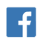
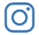
@FaithWesleyChapel
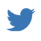
@FaithWesleyChapel
@FaithChurchWC

